The purpose of this HW was to successfully run a VBA script that would run through a raw list of data and return two different summary tables of that data. The first summary table would show a list of all the tickers per each worksheet with their Yearly Change, Percent Change, and Total Stock Volume. The other would take that data and return which Ticker had the greatest % increase during that year, which one had the greatest % decrease, and finally which one had the greatest total volume. The script would then run the same sequence for each worksheet in the excel document until there were none left to read. Below are screenshots for each worksheet on a successful run of the “Mulitple_year_stock_data” excel workbook:
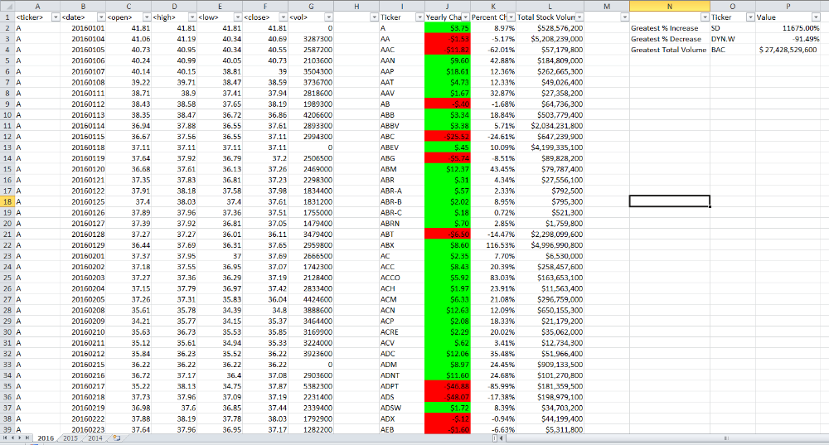
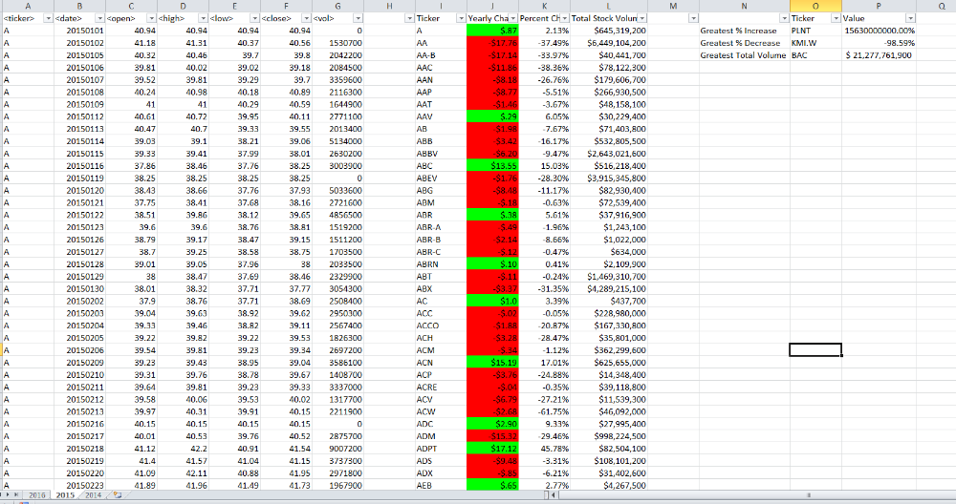
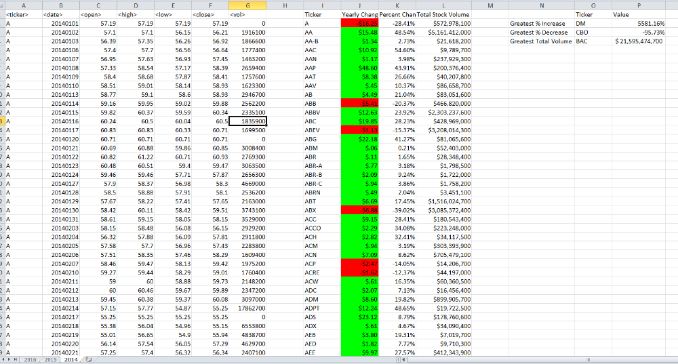

It was interesting to see that Ticker “BAC” was always the highest in stock volume. Some limitations to the data could be that the summary tables may not necessarily be an indicator of true stock performance. For instance, Ticker “AA” on the 2016 tab had a negative yearly change

In my submission, you will also find a text file of the code I used, as well as the alphabetical testing workbook which I used to test out my code.

I hope you enjoy!

